WALT explain features of coastal erosion

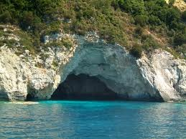
A cave is formed when _______________________________________________________________________________________________________________________________________
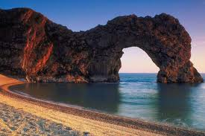
An arch is formed when _______________________________________________________________________________________________________________________________________
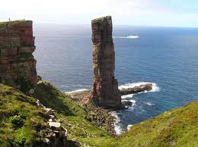
A stack is formed when _______________________________________________________________________________________________________________________________________________________________

