Focus text: The Nothing to See Here Hotel
AUDIO:https://www.worldbookday.com/stories/the-nothing-to-see-here-hotel-by-steven-butler/
You can listen to Chapter 1 and 2
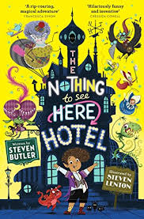 What do you think the book will be about?
What things can you see on the front cover? What sort of story will it be? Who might enjoy it?

Part 1 Vocabulary
1.What sort of physical stature does ‘dumpling’ suggest?
2.Find an example of onomatopoeia in Chapter One.
3.What word tells you that the narrator was pleased to get his granny being a troll off his chest?

Part 2 Looking Question
1.What is the narrator’s granny?
2.Who is the narrator?
3.What did Grandad Abraham used to collect?
4.Why is Frankie a quarterling?
5.What is the first sign of having troll blood?
5.Where is ‘The Nothing to See Here’ hotel?
6.How many steps are there to Granny Regutgita’s room?

Clue Questions

1.What is the big bad wolf that the author is referring to?
2.Why does no one go into the nothing to see here hotel?
3.Why is dad proud of the zero star rating?

