**English Home Learning:**

In English over the next two weeks, we are going to start looking at the three little pigs (Hopefully, you are familiar with the story!).

By the end of this week, we would like you to:

* List some adjectives you could use to describe the wolf, each of the three little pigs and their houses.
* Retell the story of the three little pigs using a story map (pictures and arrows)

Please refer to the school website for your spellings.

Reading Home Learning:

Please find attached document of pages __ of ‘The Sleeping Army’. Here are some suggested activities:

1.Please read through this and discuss the definitions of any tricky vocabulary.

2.Please practice your reading voices, making sure you emphasise key words.

3.Make a story map of what happens in the story.

4.Summarise the story in a paragraph. 5.Draw the most important part of the extract.

6. Use these questions for discussion:

|  |
| --- |
| Looking Question  1. Where are Freya and her father?  Does Freya like where she is?  Should Freya be there? |
| Clue Question  2. How is Freya’s mother feeling at the start of the story?  What words are used to describe Freya she is feeling?  What mistake did Freya’s father make? |
| Thinking Question  3. Does this story happen in our world?  What makes you think it is a different world?  What vocabulary is used to suggest that this doesn’t take place in our world? |



Y3 Home Learning Pack

*Never stop learning!*

*Week Beginning 20.04.20*

**Maths Home Learning:**

In Maths, please continue to focus on fractions. Hopefully you have managed to complete week one’s lessons on the white rose website. If you have missed them, please go back and complete these.

This week, please complete the fractions activities under week 2. Please don’t worry if you cannot print the activities out. Just doing them on a separate piece of paper is fine.

Week two’s lessons:

Lesson 1 – Step 6 – Fractions on a number line

Lesson 2 – Step 7 – Fractions of a set of objects (1)

Lesson 3 – Step 8 – Fractions of a set of objects (2)

Lesson 4 – Step 9 – Fractions of a set of objects (3)

Lesson 5 – Step 10 – Equivalent fractions (1)

If your child is finding the work too challenging, please look at the work for year 2.

<https://whiterosemaths.com/homelearning/year-3/>

**Topic Learning (Home Project):**

For the next two weeks, please investigate the ‘Iron Age’ (The period of time following The Bronze Age).

Please research where iron comes from, hillforts, farming, homes and religion. Present your work in a creative way, such as an information booklet, poster, model or PowerPoint presentation.

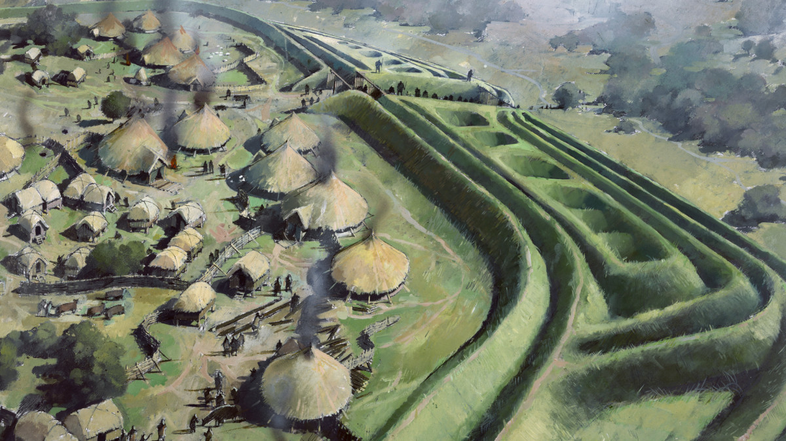

Helpful Websites for extra learning:

**Khan Academy**

[https://www.khanacademy.org](https://www.khanacademy.org/)

Especially good for maths and computing for all ages but other subjects at Secondary level. Note this uses the U.S. grade system but it's mostly common material.

**BBC Learning**

<http://www.bbc.co.uk/learning/coursesearch/>

This site is old and no longer updated and yet there's so much still available, from language learning to BBC Bitesize for revision. No TV licence required except for content on BBC iPlayer.

**Futurelearn**

[https://www.futurelearn.com](https://www.futurelearn.com/)

Free to access 100s of courses, only pay to upgrade if you need a certificate in your name (own account from age 14+ but younger learners can use a parent account).

**Seneca**

[https://www.senecalearning.com](https://www.senecalearning.com/)

For those revising at GCSE or A level. Tons of free revision content. Paid access to higher level material.

**Blockly**

[https://blockly.games](https://blockly.games/)

Learn computer programming skills - fun and free.

**Scratch**

<https://scratch.mit.edu/explore/projects/games/>

Creative computer programming

**Ted Ed**

[https://ed.ted.com](https://ed.ted.com/)

All sorts of engaging educational videos

**National Geographic Kids**

<https://www.natgeokids.com/uk/>

Activities and quizzes for younger kids.

**Duolingo**

[https://www.duolingo.com](https://www.duolingo.com/)

Learn languages for free. Web or app.

**Language Angels**

Access the Language Angels games and learn some

Spanish. Username: littlegreen. Password: pupil20

**TimesTable RockStars**

Let’s get Little Green up the league table!

**Twinkl**

Free access to lots of education resources for a month. You just need to set up an account.

**Nrich.maths.org**

A website with challenging Maths problem solving activities.

**Whiterosemaths.com**

Free Maths planning and resources, including problem solving.

Suggested Daily Structure:

We suggest you follow a timetable similar to below to help you structure your learning throughout the day.

· Try to avoid too much screen time and make sure you get out and do some exercise.

· Try to avoid snacking at unusual times. It might be useful to keep to school break times and lunchtimes to help you know how much to eat and when.

· Keep up with your normal reading, spelling and times table activities.

**Morning Learning**

*9.00-10.00*

**Active Time and fresh air (maybe a walk?)**

*10.10-10.40*

**Break and a snack**

*10.40-11.00*

**Creative Time (do some art,**

**maybe outdoors, build something?)**

*11.00-12.00*

**Lunch and active time**

*12.00-1:00*

**Afternoon Learning**

*1:00-2.00*

**Active Time (maybe a walk?)**

2:00-2:30

**The School Website:**

**This is vital as we may put learning or even tutorials up on here to support you.**

**www.littlegreen.herts.sch.uk**

**LoveReading4Kids:**

**If you haven’t already, make an account on www.lovereading4kids.com to explore book extracts, and to access the extracts the we send home for reading learning.**