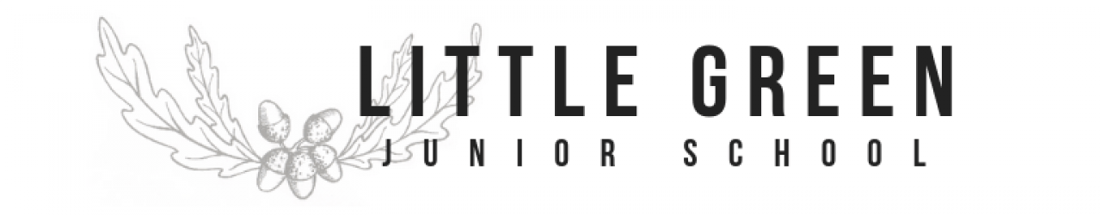
Year 4 Home Learning Pack Never stop learning!
Maths Home Learning:  In Maths, please keep practicing times tables on the websites suggested last week.  Please go to the website: https://whiterosemaths.com/homelearning/year-4/  Lesson 2- Write decimals  Watch the video and then complete the worksheet provided on the website. Answers are also available for you or your child to check.  Activity - Angles  We will be exploring angles this week. Please read, watch and interact with the following webpages:  https://www.bbc.co.uk/bitesize/topics/zb6tyrd/articles/zg68k7h  https://www.bbc.co.uk/teach/supermovers/ks2-maths-2d-shapes-with-radzi/zvfjbdm  Begin with a hunt for different angles in objects at home or in a garden.  Look at the maths angle sheet (on website)  Identify the different angles and answer the questions  These questions will be posted on Google classroom for you to answer if you can. | Science  Watch the video on the School Run website:  https://www.theschoolrun.com/what-are-states-of-matter  Complete the interactive worksheet about States of matter with link below  https://www.twinkl.com/go/sign-in  PIN:QZ1730  OR Print off 1 of the worksheets and complete.  Part 2  https://www.bbc.co.uk/bitesize/clips/zmbygk7  Watch the video in the link above.  How many gases can you spot?  Investigation  Is this plastic bottle empty?  Resources: A plastic bottle with a lid on.  1. Take a plastic bottle with the lid tightly on and try and squash it flat. Why can’t you flatten it?  2. Take the lid off the bottle. Try squashing the bottle now. Why can you flatten it? Can you explain what happens and why? | Reading Home Learning:  Focus: Non Fiction (Text on website or google classroom)  Look at one of the texts.( 1 star=Bronze, 2 star=Silver 3 star= Gold  1. Can you identify the features of a non-fiction text?  2. Read the text and answer the questions underneath.  Mark your work using the answers.  English Home Learning:  In English, as part of our Poetry topic, we are looking at a poem entitled ‘Overheard on a salt marsh.’  This poem is also linked to Geography and our Coasts topic.  Please find the poem and geography powerpoint on the school website or in the Google classroom. These tasks are clearly laid out in order and contained in one PowerPoint.  Please complete the Geography task first, so that you understand what salt marshes are before you begin the English tasks.

