Dear Parent/Guardian,

We have a wonderful start for next term! On Friday 10th January we are delighted to be welcoming the utterly brilliant Lissa Evans, author of children’s books and a host of novels for adults, BAFTA award winning producer of TV’s Father Ted and “a marvel, a genuinely funny, clever writer who takes you to the last place you expect to go.” (The Times)
Lissa will be joining us to speak about her work as a writer and her latest book Big Change for Stuart, the much anticipated sequel to Small Change for Stuart which was shortlisted for the Carnegie Medal, the Costa Book Awards, the UK Literacy Award and the Branford Boase Award.

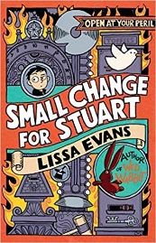
In Small Change for Stuart Stuart Horten, ten years old and small for his age, is about to have the strangest adventure of his life. After moving to the boring town of Beeton, he finds himself swept up in a quest to find his great-uncle's lost legacy: a magician's workshop stuffed with trickery and magic. There are clues to follow, unbearable neighbours to avoid and puzzles to solve, but what starts as fun ends up as danger, and Stuart begins to realise that he can't finish the task on his own...

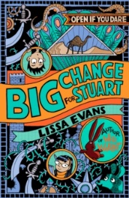
Praise for Small Change for Stuart: ‘One of the year’s great delights. It’s a finely written book crammed with exciting incident and colourful characters; something quite special.’ (Independent on Sunday)
Big Change for Stuart has magic, mystery and a very dangerous quest. Stuart Horten (aged 10 but looks younger) is now the owner of a Magician's Workshop - a treasure trove of illusions and the gateway to seven magical adventures. Except that without his great-uncle's last will and testament, Stuart can't prove the workshop is his. Can he solve the puzzles and find the will before it's too late? Or will the looming danger and increasing risks ruin his friendships for good?

Praise for Big Change for Stuart: ‘A story fluctuating between humour and high drama. The first story about this likeable boy, published last year, came out to universal praise. The second one is just as good.’ (Independent on Sunday)

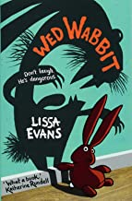
Lissa’s first book for children, Wed Rabbit, was shortlisted for the Carnegie Award, Costa Children’s Book Award and the Blue Peter Award and has been described as “… a classic in the making. An unmissable literary carrot” by The Times.

If your child would like to meet Lissa and buy a signed copy of her books, please complete the form below and return it to your child’s form teacher with the correct money (cheques made payable to ‘Chorleywood Bookshop’) by Tuesday 4th January.

Book | Price | Number of copies
Big Change for Stuart | RRP £6.99
Small Change for Stuart | RRP £6.99
SPECIAL BUNDLE PRICE  Small Change for Stuart & Big Change for Stuart | £12  (RRP £13.98)
Wed Rabbit | RRP £6.99
Total Amount |  | £

Child’s name …………………………………………………………………… Form ……………..…

