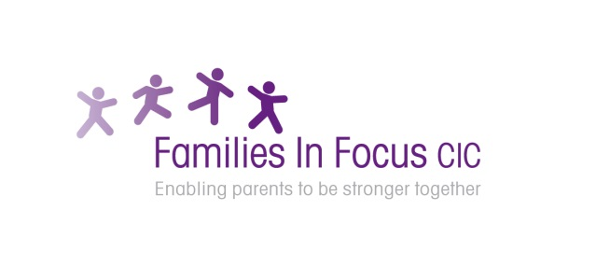

**Workshop for dads, grandads, male adoptive, foster carers to get together with others caring for children/young people with Autism, ADHD, special education needs etc and share experiences, knowledge and information.**

**30th September:** Emotional journey & and effects on relationships when parenting children with SEND

**11th November:** Managing your stress

**20th January:** Parents guide to body changes & hygiene for young people with SEND

**9th March**: Using empathic communication to build emotional regulation

**Where:**

**Otley Family Centre**

**Otley Way**

**Watford**

**Hertfordshire**

**WD19 7TB**

**Time: 7pm to 9pm**



2 hour workshops ‘Just for Dads’ caring for children with special needs and/or disabilities living in the Watford, Bushey, Radlett & Three Rivers areas – funded by DSPL 9

**To book your free place on contact Francine & Lesley: bookings@familiesinfocus.co.uk**

Families in Focus ***Just for Dads*** Guide to……

DSPL area 9 Supporting families of children with SEND in Watford, Bushey, Radlett & Three Rivers



Families in Focus Parent Network support & guidance groups in Hemel Hempstead, Watford, St Albans and Stevenage

Website: [**www.familiesinfocus.co.uk**](http://www.familiesinfocus.co.uk)Email: [**info@familiesinfocus.co.uk**](mailto:info@familiesinfocus.co.uk) Tel: **01442 219 720**

*FREE*