Dear Parent/Guardian,

On Wednesday 6th November we are delighted to be welcoming the extraordinarily talented Sita Brahamachari, multi award-winning author of many novels and short stories for children and young adults.

Sita will be joining us to speak about her work as a writer and her latest critically acclaimed book Where the River Runs Gold, a bold adventure, breathtakingly written with timely climate change themes.

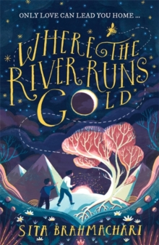
Shifa and her brother, Themba, live in Kairos City where few live in luxury, whilst the millions like them crowd together in compounds, governed by Freedom Fields - the organisation that looks after you, as long as you opt in.

The bees have long disappeared; instead children must labour on farms, pollinating crops by hand so that the nation can eat. The farm Shifa and Themba are sent to is hard and cruel, and Shifa comes up with a plan to break them out.

But they have no idea where they are - their only guide is a map drawn from the ramblings of a stranger. The journey ahead is fraught with danger, but Shifa listens to her instincts - to let love guide them home. The freedom of a nation depends on it.

'Lavishly written and full of love of the natural world.' - Sunday Times

Sita will be signing copies of Where the River Runs Gold on the day. If you would like to buy a signed copy, please complete the form below and return it to your child’s form teacher with the correct money (cheques made payable to ‘Chorleywood Bookshop’) by Monday 4th November.

Book | Price | Number of copies
Where the River Runs Gold | £6.99
Total Amount |  | £

Name ……………………………………………………………………… Class ……………..…

