Little Green School
Wear Something Red for Comic Relief
2019
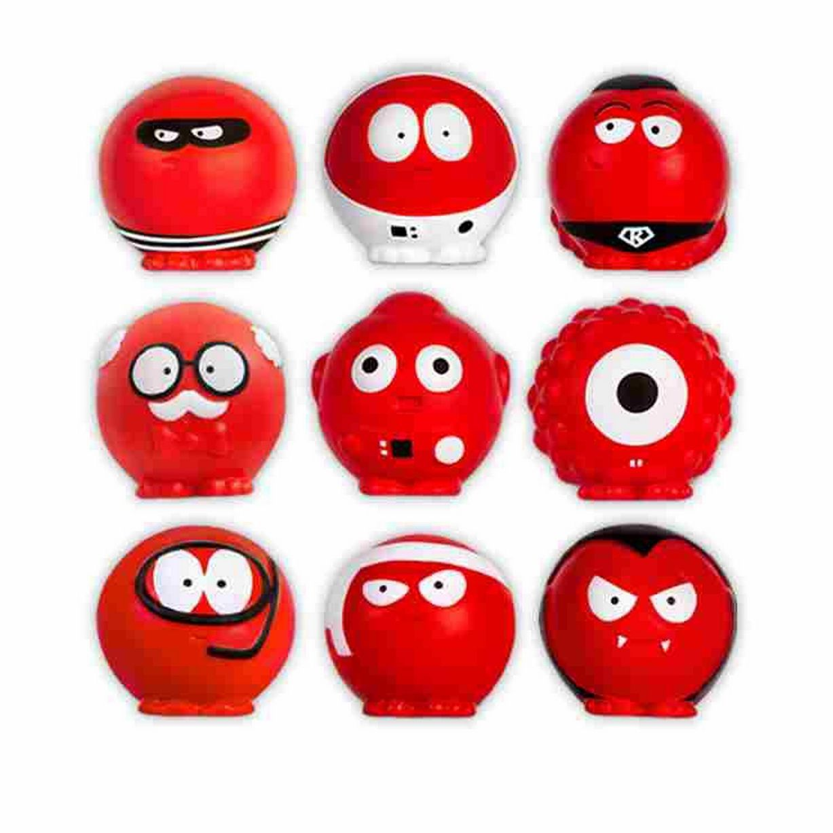 A huge thank you to all children, parents, carers and staff for supporting Comic Relief 2019 by raising a massive £354

