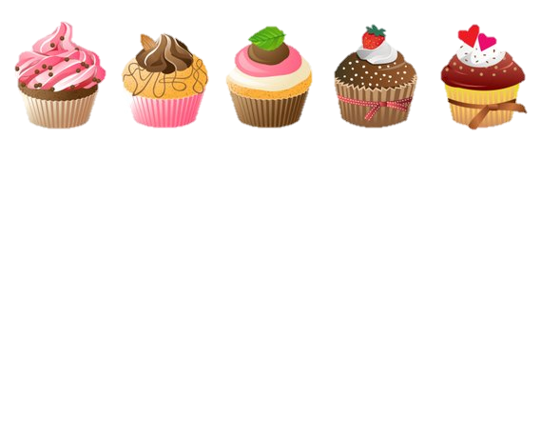

**P.A.L Cake Sale**

Any further donations are greatly appreciated! 😊

We are a **NUT FREE** school:

Absolutely no nuts, sesame seeds or oils.

Held at Little Green Junior school on:

- **7th March**, at **Lunch time in Acer class** **(for pupils only)** and **after school** in the **lower playground gazeebo** **(for parents and carers)**

- **8th March after school** in the lower **playground gazeebo *(for parents and carers)***

***Prices:***

Small items: 50P

Medium items: £1.00

Large slices: £1.50



If you wish to ***donate*** baked goods, whether homemade or bought, please ***send them in with your child to Maple Class on the Thursday or Friday morning.***

***(If you have made the cakes please provide an*** *ingredients list* ***and if bought, please leave them in their packaging- Thank you!)***



The P.A.L journey:

Mental health in primary schools looks good, right? Wrong, look again! An estimated 3 children in every classroom suffer from a diagnosable mental health problem. How can we change this? Maple class have worked really hard to create P.A.L (Positive Attitude Log) a mental health activity book for children. It is due to be shared within mental health conferences and with mental health charities. We need to raise £800 to get it published with its own ISBN number. Please help us to make a real difference to mental health within our local community and beyond!

#HaveaPALwhenyouneedapal

***This is a community wellbeing event. Where possible, we would like to see as many parents, carers and families attending as we can!***

